Name of Student : Raghav Mahesh Sarda PRN: 25070122235
Subject: Programming with Java Semester: III
ASSIGNMENT No : 16 Year: AY 2026-27
TITLE : User-Defined Exceptions

Problem Statement
Write a Java program to create and handle a user-defined exception.

Learning Objectives
To create and implement custom exceptions for application-specific error handling.

Program:
BankAccountSystem.java
// Assignment 16 - Exercise 1: Bank Account with User-Defined Exception
import java.util.*;
class InsufficientFundsException extends Exception // Custom user-defined exception class
{
InsufficientFundsException(String msg) // Constructor
{
super(msg); // Passing message to parent Exception class
}
}

class BankAccount
{
double balance;
BankAccount(double bal) // Constructor
{
balance = bal; // Initializing balance
}
void withdraw(double amt) throws InsufficientFundsException // Method throwing user-defined exception
{
if(amt > balance) // Insufficient balance condition
{
throw new InsufficientFundsException("Withdrawal failed: Entered amount exceeds available balance!"); // Throwing custom exception
}
else // Valid withdrawal
{
balance = balance - amt; // Deducting amount
System.out.println("Withdrawal successful! Remaining Balance: $" + balance); // Message
}
}
}

public class BankAccountSystem
{
public static void main(String args[]) // Main Method
{
Scanner sc = new Scanner(System.in);
System.out.print("Enter Initial Account Balance: ");
double initialBal = sc.nextDouble();
BankAccount acc = new BankAccount(initialBal); // Creating account object

System.out.print("Enter Amount to Withdraw: ");
double withdrawAmt = sc.nextDouble();

try
{
acc.withdraw(withdrawAmt); // Attempting withdrawal
}
catch(InsufficientFundsException e) // Catching user-defined exception
{
System.out.println("Custom Exception Caught -> " + e.getMessage()); // Handling custom exception
}
finally
{
System.out.println("Banking transaction completed."); // Status message
sc.close();
}
}
}
VotingRegistration.java
// Assignment 16 - Exercise 2: Age Validation with User-Defined Exception
import java.util.*;
class InvalidAgeException extends Exception // User-defined exception class
{
InvalidAgeException(String msg) // Constructor
{
super(msg); // Passing error message to superclass
}
}

public class VotingRegistration
{
static void checkEligibility(int age) throws InvalidAgeException // Method declaring custom exception
{
if(age < 18) // Eligibility check condition
{
throw new InvalidAgeException("Candidate is under 18 years old and ineligible to vote."); // Throwing custom exception
}
else // Valid age condition
{
System.out.println("Eligible");
}
}

public static void main(String args[]) // Main Method
{
Scanner sc = new Scanner(System.in);
System.out.print("Enter Candidate Age: ");
int userAge = sc.nextInt();
try
{
checkEligibility(userAge); // Calling validation method
}
catch(InvalidAgeException e) // Catching custom exception
{
System.out.println("Registration Rejected -> " + e.getMessage()); // Error message
}
finally // Finally block
{
System.out.println("Voter verification process finished.");
sc.close();
}
}
}

Output:
BankAccountSystem.java
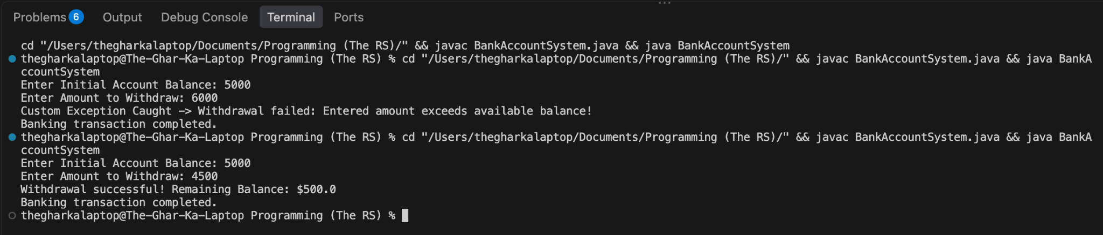

VotingRegistration.java
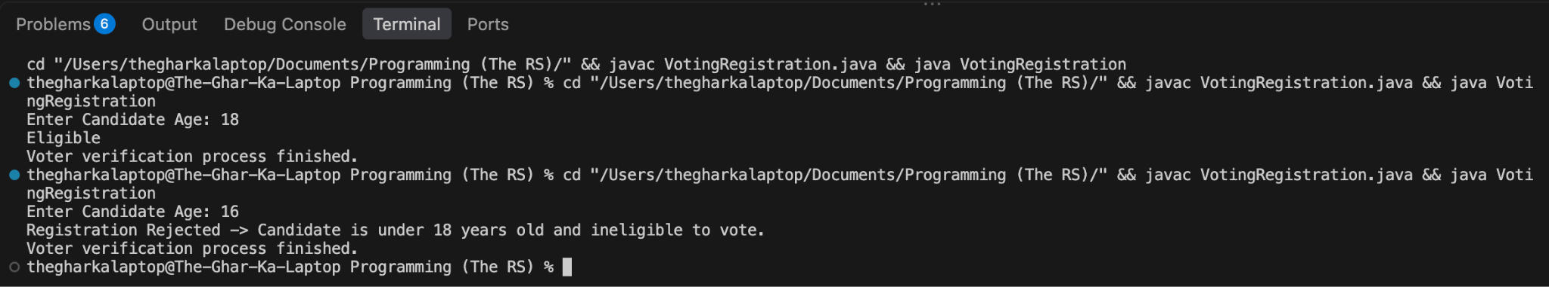

Conclusion:
In this assignment, the concepts of custom error handling using user-defined exceptions were successfully implemented and verified. Custom exception classes extending the Exception base class provided domain-specific validation for banking transactions and age verification, enabling error reporting and maintaining program stability against improper user inputs.

